**

**Mathematics Specialist Unit 2 2021**

# Test 4

**Trigonometric Identities and Matrices**

|  |
| --- |
| **Name: ______________________ Total Marks:__________** |
|  |
|  |

**Task type: Response**

**Time allowed for this task: 60** minutes, in-class, under test conditions

Section One: Calculator-free 42 minutes ( 39 marks)

(3 Minutes Reading – 40 Minutes Working)

Section Two: Calculator-assumed 16 minutes ( 15 marks)

(2 minutes Reading - 15 minutes working)

**Materials required:** Calculator with CAS capability (to be provided by the student)

**Standard items:** Pens (blue/black preferred), pencils (including coloured), sharpener, correction fluid/tape, eraser, ruler, highlighters

**Special items:**  Drawing instruments, templates, notes on one unfolded sheet of   
A4 paper, and up to three calculators approved for use in the WACE examinations

Formula sheet

**Marks available: 54 marks**

**Task weighting: 6%**

**Section One : Calculator Free 39 Marks**

**Time Allowed 30 minutes**

Question 1 (8 marks)

For the following matrices

$A=\left[\begin{matrix}4 & -1 \\ 5 & 0\end{matrix}\right]$ $B=\left[\begin{matrix}6 & -2 \\ 7 & -2\end{matrix}\right]$ $C=\left[\begin{matrix}-2 \\ 7\end{matrix}\right]$

Determine the following, if not possible explain why.

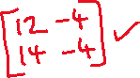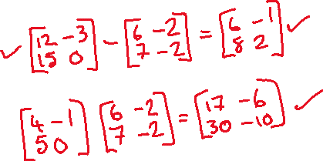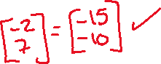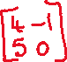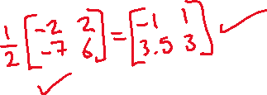

Question 2 (3 marks)

Use a matrix method to solve the system of equations $5x-2y=14$ and .

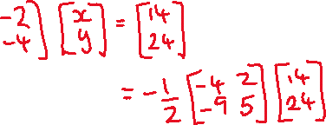

Question 3 (6 marks)

Find all the solutions to the following equations

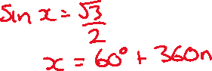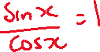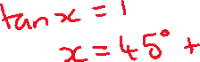

Question 4 (8 marks)

Let $A=\left(\begin{matrix}1 & 0 \\ 5 & 1\end{matrix}\right), B=\left(\begin{matrix}p & 6 \\ 2 & p+1\end{matrix}\right), C=\left(\begin{matrix}-2 \\ 1\end{matrix}\right)$ and $D=\left(\begin{matrix}-8 \\ 4\end{matrix}\right)$, where $b$ is a constant.

1. Determine matrix B if

$BC=D$

(2 marks)



* 1. is singular

(3 marks)

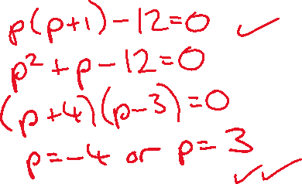

1. Use a matrix method to determine $X$ if $3X=4C-AX$. (3 marks)

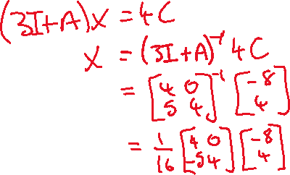

Question 5 (7 marks)

1. State the exact value of $\sec{\frac{π}{3}}$

(2 marks)



1. Given that $cosec θ=\begin{matrix}5 \\ \overline{4}\end{matrix}$ and $\frac{π}{2}≤θ≤π$, state the exact value of $\sec{θ}$

(3 marks)

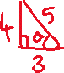

1. Sketch the graph of $y=2\operatorname{cosec}{(x+\frac{π}{2})}$ on the grid below.

(3 marks)

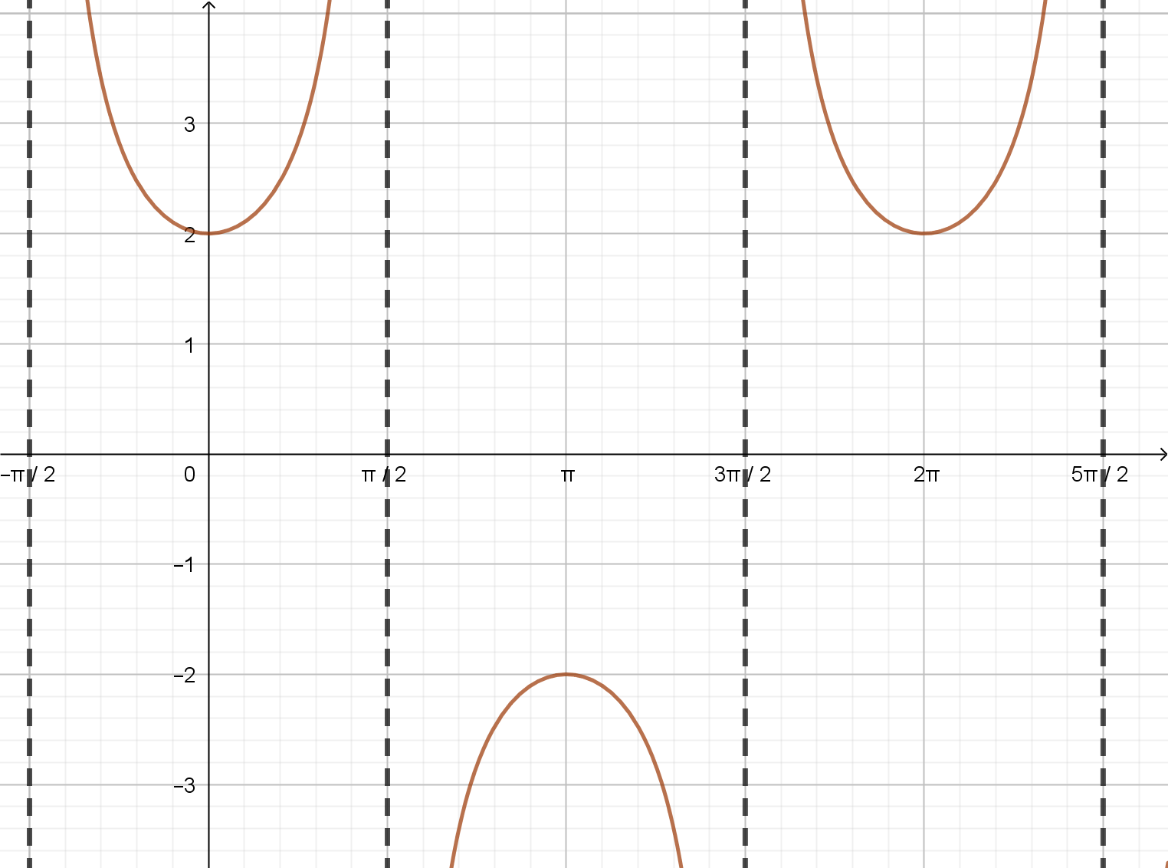

Question 6 (7 marks)

1. Use the identity $\cos\left(A±B\right)=\cos{A}\cos{B}∓\sin{A}\sin{B}$ to prove $\cos{2A}=2\cos^{2}A-1$

(3 marks)

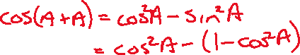

1. Hence solve $\cos{2A}=\cos{A}$, for $-π≤A≤π$.

(4 marks)

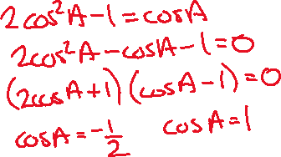

**Section Two : Calculator Assumed 15 Marks**

**Time Allowed 30 minutes Name:_______________________**

Question 7

(5 marks)

The function $f\left(x\right)=a\tan{(b(x+c)}$ is graphed below.

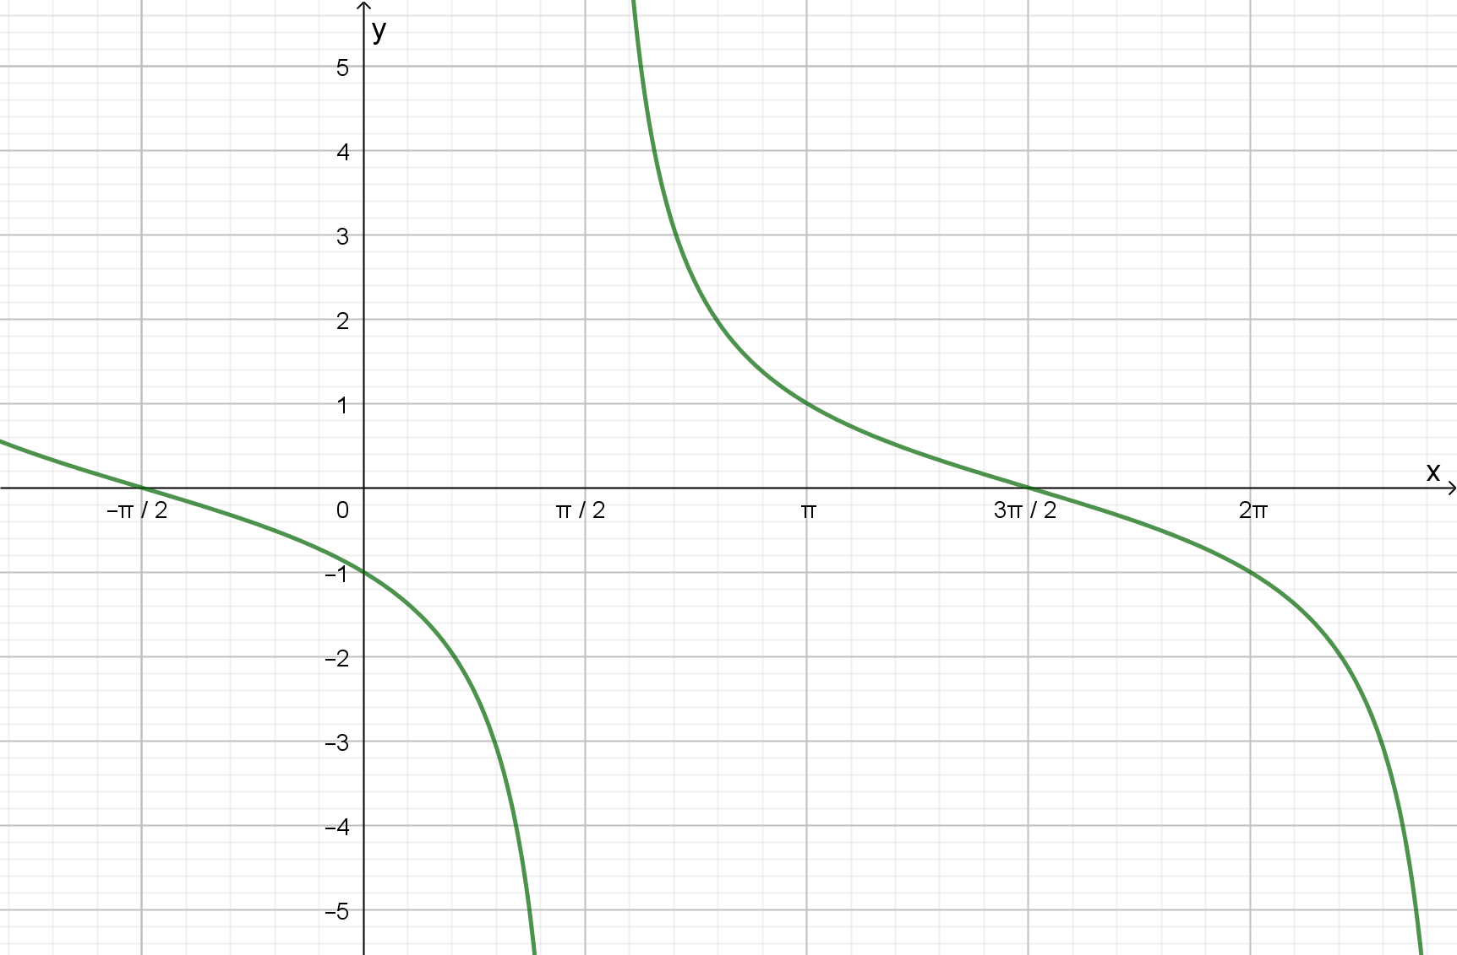

1. Determine the values of the constants $a, b,$ and $c$.



$a=-1 b= 0.5 c=π/2$

1. Find the general solution for $f(x)=1$



Question 8

(10 marks)

Starting at midnight ($t=0$), the temperature $T$ at a campsite was observed to vary sinusoidally over the course of the day, reaching a high of $17.9°$ C at $1$ pm after a low of $-2.3°$ C at $1$ am. Let $t$ be the time in hours from midnight.

1. Use the above information to sketch a graph showing how $T$ varies with $t$ during the day.

(3 marks)

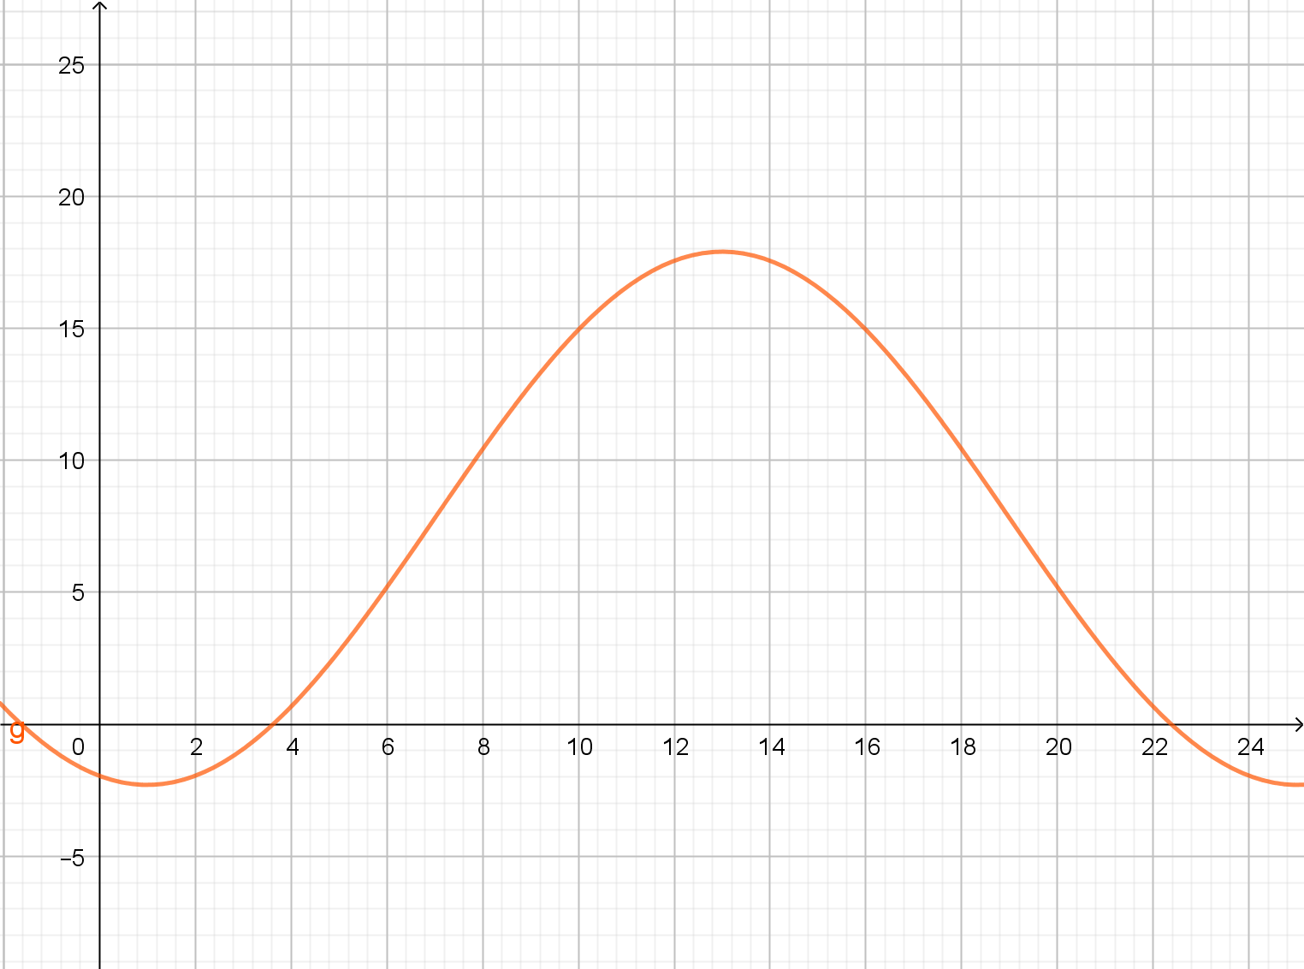

1. Determine an algebraic model for $T$ as a function of $t$. (4 marks)

|  |
| --- |
| **Solution** (Using cos) |
| Model with $T=c-a\cos\left(k\left(t+b\right)\right)$ Using period: $k=\frac{2π}{24}=\frac{π}{12}$ Amplitude: $a=\frac{17.9-(-2.3)}{2}=10.1$ Mean temp: $c=17.9-10.1=7.8$ Phase shift: $b=-1$ $$T=7.8-10.1\cos\left(\frac{π}{12}\left(t-1\right)\right)$$ |
| **Specific behaviours** |
| ✓ indicates period, value of $k$ ü amplitude $a$ and mean $c$ ü phase shift  ü correct model |

|  |
| --- |
| **Solution** (Using sin) |
|  |
| Model with $T=a\sin\left(k\left(t+b\right)\right)+c$ Using period: $k=\frac{2π}{24}=\frac{π}{12}$ Amplitude: $a=\frac{17.9-(-2.3)}{2}=10.1$ Mean temp: $c=17.9-10.1=7.8$ Phase shift: $b=-7$ $$T=10.1\sin\left(\frac{π}{12}\left(t-7\right)\right)+7.8$$ |
| **Specific behaviours** |
| ✓ indicates period, value of $k$ ü amplitude $a$ and mean $c$ ü phase shift  ü correct model |

1. Use your model to determine the time of the day that the temperature at the campsite falls below $0°$ C. (3 marks)

